|  |  |
| --- | --- |
| 931755449 | https://www.sciedupress.com/journal/index.php/wjel/issue/archive |

Go to the website usin based url.

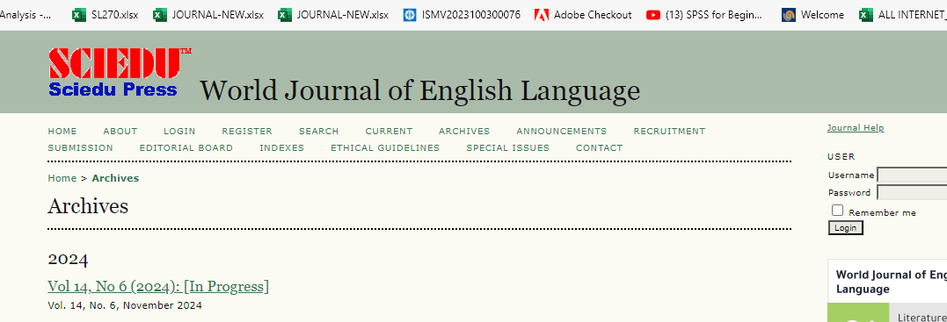

Capture issue

Click latest issue from here

You will get page like below

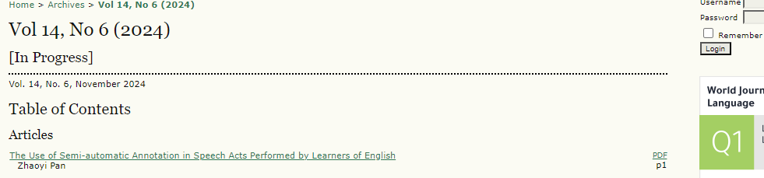

Capture volume

Capture month

Capture year

Page range

Capture and Click article title

After clicking article title you will get article page like below.



Click here to download pdf

Capture DOI